**Batch file processing**

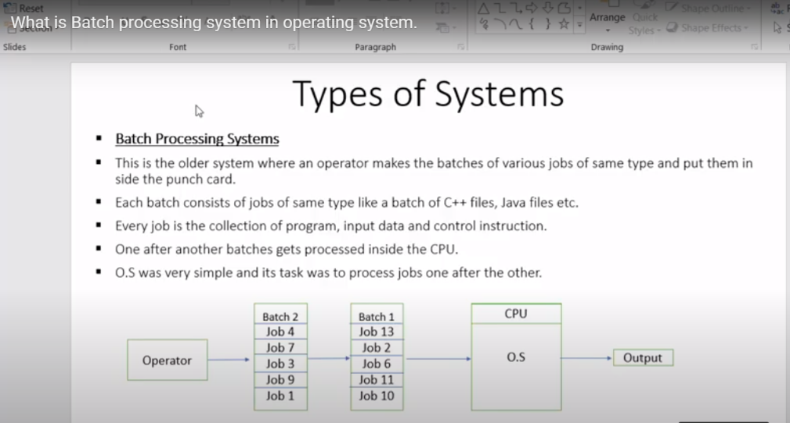

**There are two types of process will be there**

**1.Batch process-> get the data,store in some place then run the batch file->eg: taking the movie shots on long day before but edit and put the movie in diwali time**

**2.stream process->get the data and process it at a time->eg: live tv show,cricket matches,railway ticket booking once you booked means it show that confirm ticket booking,Atm money Withdrawl**

**Front end 🡪data get from front end->process the data(it will be daily data,monthly data,weekly data)**

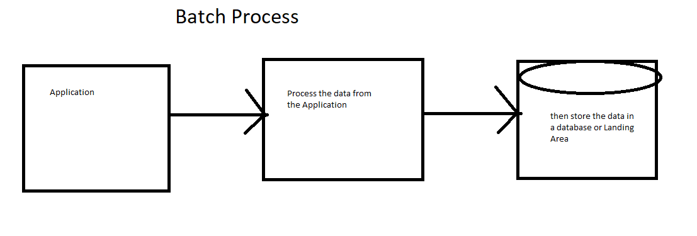

**Application ->Landing ->Process**

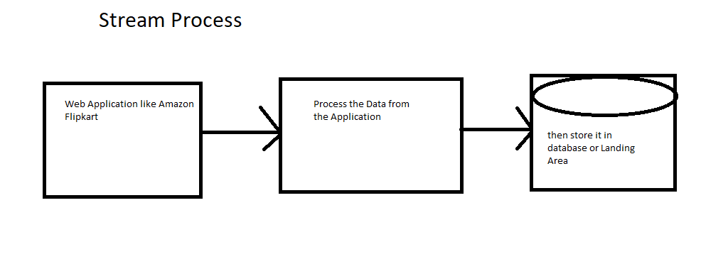

**Application->Process->Landing**

**Batch process->it will run for certain period of time**

**Stream process->it will run for 24*7 at any time**

**1.Reader**

**2.Writer**

**3.Processor**